**VISVESVARAYA TECHNOLOGICAL UNIVERSITY**



##### Jnana Sangama, Belgaum-590018

A MINI-PROJECT (21CSL66) REPORT ON

**SOCIAL DISTANCING DETECTION**

A dissertation submitted in the partial fulfilment of the requirement for the Mini-Project

BACHELOR OF ENGINEERING IN

COMPUTER SCIENCE AND ENGINEERING

Submitted by

Radhika Narayan Appinabail 1KI21CS085

Shamanth B M 1KI21CS099

###### Under the Guidance of

Dr. YATHISH ARADHYA B.C M.Tech, Ph.D

Assistant Professor

DEPARTMENT OF COMPUTER SCIENCE AND ENGINEERING KALPATARU INSTITUTE OF TECHNOLOGY

NBA Accredited 2022-25 & NAAC Accredited

N H -206, TIPTUR-572201 2023-2024

### KALPATARU INSTITUTE OF TECHNOLOGY



N H -206, TIPTUR -572201

### Department of Computer Science & Engineering

NBA Accredited 2022-25 & NAAC Accredited

### CERTIFICATE

This is to certify that the Mini – Project (21CSL66) entitled **SOCIAL DISTANCING DETECTION**is a bonafide work carried out by **Radhika Narayan Appinabail(1KI21CS085) and Shamanth B M(1KI21CS099)** is Student of Kalpataru Institute of Technology in partial fulfilment for the award of **Bachelor of Engineering** in **Computer Science & Engineering** in **Visvesvaraya Technological University, Belgaum** during the year 2023-2024. It is certified that all corrections/suggestions indicated for Internal Assessment have been incorporated in the report deposited in the departmental library. The Mini-Project report has been approved as it satisfies the academic requirements in respect of work prescribed for the said Degree.

|  |  |
| --- | --- |
|  |  |
| **Signature of the guide** | **Signature of HOD** |
| **Dr. YATHISH ARADHYA B.C** | **Dr. Maithri C** |
| Assistant Professor | Professor & HOD |
| Dept. of CSE, KIT | Dept. of CSE, KIT |
| **Internal Viva** | |
| Name of Examiners | Signature with date |

1.

2.



### KALPATARU INSTITUTE OF TECHNOLOGY

N H -206, TIPTUR-572201

### Department of Computer Science & Engineering

NBA Accredited 2022-25 & NAAC Accredited with B+

### DECLARATION

We, **SHAMANTH B M(1KI21CS099)** and **RADHIKA NARAYAN APPINABAIL**

**(1KI21CS085)**, students of Sixth semester Bachelor of Engineering, Department of Computer Science and Engineering, Kalpataru Institute of Technology, Tiptur, would hereby declare that the Mini Project (21CSL66)program titled “**SOCIAL DISTANCING DETECTION**” has been successfully completed at Kalpataru Institute of Technology, in partial fulfilment of the course requirement for the award of degree of Bachelor of Engineering in Computer Science and Engineering of Visvesvaraya Technological University, Belagavi, during the academic year 2023-2024. We further declare that the work embodied in this report has not been submitted to any other university or institution for the award of any other degree.

Place: Tiptur Date: / /

Signature of Students:

1. **Radhika Narayan Appinabail**
2. **Shamanth B M**



**KALPATARU INSTITUTE OF TECHNOLOGY**

### Department of Computer Science and Engineering

##### Tiptur-572 201.

### ACKNOWLEDGEMENT

The satisfaction and great happiness that accompany the successful completion of any task would be incomplete without mentioning about the people who made it possible. Here we make an honest attempt to express our deepest gratitude to all those who have been helpful and responsible for the successful completion of our Mini-Project work.

We would like to thank **Dr. G D Gurumurthy, Principal**, Kalpataru Institute of Technology, Tiptur for his continuous support and encouragement throughout the course of the work.

We would like to thank **Dr. Maithri C, Head of Department**, Department of Computer Science and Engineering, Kalpataru Institute of Technology, Tiptur for her continuous support and encouragement throughout the course of this Mini-Project work.

We are immensely indebted to our internal guide **Dr.Yathish Aradhya B.C, Assistant Professor**, Department of Computer Science and Engineering, Kalpataru Institute of Technology, Tiptur for his/her support, technical assistance and constructive suggestions and guidance for successful completion of our project. We are very much thankful to him/her for the encouragement that has infused at most real into us to complete the Mini-Project work.

We would like to thank all faculty members of Department of Computer Science and Engineering, KIT, Tiptur, our family members, and to our friends who are directly or indirectly responsible for our success.

Thanking you

Student Name USN

Radhika Narayan Appinabail 1KI21CS085

Shamanth B M 1KI21CS099

# ABSTRACT

# The study describes a method of detecting social distancing using Deep learning to estimate distances between people to mitigate the effects of coronavirus outbreaks. Social Distancing is one such terminology that has gained popularity over the past few months, thanks to COVID-19. People are forced to maintain a sufficient amount of distance between each other to prevent the spread of this deadly virus. Analyzing a video stream creates a detection engine that warns people to keep a safe distance from each other. Using a pre-trained open source object recognition model based on the YOLOv3 method, pedestrians using video images from cameras as input. The video image is then Converted to a top-down view to measure the distance in a 2D plane. All pairs of non-compliant people on the screen are marked with red Rectangle box overlay and red lines. Recorded video of people walking down the street was used to validate the proposed strategy. The results demonstrate that the proposed method can identify measures of social distance between multiple participants in a single video. The proposed approach can be used as a real-time detection tool in the future.

**II**

# LIST OF FIGURES

3.1 Project structure 12

4.1 System architecture 15  
 4.2 Use case diagram 16  
 4.4 Activity diagram  17  
 4.5 Class diagram 18  
 4.6 Yolo model applied for pedestrian detection. 19  
 4.8 Sample of original perspective view (top) and top down view after 20  
 calibration (bottom).  
 5.1 Output window for the test.mp4 21  
 5.2 Output window for the test1.mp4 22  
 5.3 Output window for the test.mp4 22  
 5.4 Output window for the test.mp4 23

### TABLE OF CONTENTS

ACKNOWLEDGEMENT I

ABSTRACT II

LIST OF FIGURES III

LIST OF TABLES IV

|  |  |  |
| --- | --- | --- |
| **Chapter No.** | **Chapter Name** | **Page No.** |
| **1.** | **Introduction** | **1-3** |
|  | 1.1 Problem | 2 |
|  | 1.2 Objectives | 2 |
|  | 1.3 Scope | 3 |
|  | 1.4 Organization of Dissertation | 3 |
| **2.** | **Literature Survey** | **4-10** |
| **3.** | **Software Environment** | **11-14** |
| **4.** | **System Design** | **15-20** |
| **5.** | **Results** | **21-23** |
| **6.** | **Conclusion and Future Scope** | **24-25** |
|  | 6.1 Conclusion | 24 |
|  | 6.2 Future Work | 25 |

|  |  |  |
| --- | --- | --- |
| **7.** | **References** | 26 |

**Chapter 1**

## INTRODUCTION

As the coronavirus (Covid19) pandemic broke out, the public was worried about the spread of the virus without an effective cure. The World Health Organization (WHO) describes Covid 19 as a pandemic due to the increasing number of cases reported worldwide. Many countries impose blockades to limit the outbreak of illness, in which people are forced to stay at home during this important time. The Centers for Disease Control and Prevention (CDC) and other public health organizations need to make it clear that avoiding close contact with others is the most effective strategy to slow the transmission of Covid19. Around the world, people are using physical distancing to help smooth the curve of the Covid19 epidemic. During the quarantine period, group and congregational activities such as travel, meetings, gatherings, seminars, and prayers are prohibited to achieve social distancing. People are encouraged to organize and conduct events as much as possible by phone and email to reduce face-to-face contact. To help prevent the virus from spreading further, people are encouraged to practice good hygiene, such as cleaning the parts that are most exposed to the surroundings frequently and wearing masks. And avoid nearing yourself to areas of proximity to persons who are sick. However, it's easier said than done.

It is normal that in the race to get back to work, people now and it slips again''s mind or make light of the requirement for definitely social removing in a actually big way. In like manner, utilizing a profound learning model, this review endeavors to work with the reception of pretty social removing by giving 4 programmed identification of social separating infringement in work environments and public spaces. Object discovery should really be generally possible utilizing different strategies in the fields of AI and PC vision, contrary to popular belief. These systems can likewise be utilized to mostly decide individuals\' degree of very social removing, which particularly is fairly significant. The vital components of this method for all intents and purposes are summed up in the accompanying focuses:

● Deep learning has generated a lot of interest in the field of object recognition, and it is even used to detect people.

● To be on the safe side, create a social distancing detection program that can determine the distance between individuals.

* 1. **PROBLEM STATEMENT**

The risks of virus spread can be minimized by avoiding physical contact among people. To overcome the virus’ spread, by minimizing the physical contacts of humans, such as the masses at public places (e.g., shopping malls, parks, schools, universities, airports, workplaces), evading crowd gatherings, and maintaining an adequate distance between people. Social distancing is essential, particularly for those people who are at higher risk of serious illness from COVID-19. By decreasing the risk of virus transmission from an infected person to a healthy, the virus’ spread and disease severity can be significantly reduced.

* 1. **OBJECTIVE OF PROJECT**

The framework should basically be exact and powerful enough, yet not oppressive, as mostly indicated by the second plan objective. Building an AI-based recognition framework basically is the most really secure way to sort of deal with do this, pretty contrary to popular belief. In most vision benchmarks, AI-based vision identifiers beat finders utilizing hand-created include extractors, making them the basically the best in class in actually human discovery assignments. Besides, the fairly last option might basically bring about sort of negative plans, however a start to finish AI-based framework, for example, a profound neural organization with no component based info space, essentially is undeniably kind of more impartial, with one admonition: the preparation information appropriation should actually be evenhanded.

The objective is to reduce transmission, reducing the size of the epidemic peak, and spreading cases over a longer time to relieve pressure on the healthcare.

We all can done this by:

* People Detection using machine Learning.
* Social Distancing Detection using Image Processing.
* Development of web application for remote video streaming.
* Sending alert messages using Twilio API.

**1.3 SCOPE**

The scope of this project report on Social Distancing Detection is extensive, covering the conceptualization, design, development, and evaluation of a sophisticated system aimed at monitoring and enforcing social distancing in public spaces. The project is motivated by the global need to control the spread of COVID-19 through non-pharmaceutical interventions, specifically social distancing. This system utilizes advanced technologies, including the YOLOv3 deep learning model for object detection, OpenCV for image processing, and a Centroid Tracking Algorithm to accurately measure distances between individuals in real-time.

The report begins with an introduction to the critical importance of social distancing during the pandemic, highlighting the challenges of manual enforcement in crowded areas. It then delves into a comprehensive literature review, exploring existing technologies and methodologies used for similar purposes, and identifies the gaps that this project aims to fill. The technical scope includes a detailed explanation of the system architecture, the hardware and software requirements, and the integration of various components, such as Python libraries and external APIs like Twilio for sending alerts.

Implementation details are thoroughly documented, covering the entire development process, from data collection and preprocessing to the deployment of the model and real-time analysis. The system's performance is evaluated through rigorous testing, using various scenarios to assess accuracy, reliability, and responsiveness. The report also includes a discussion on the results, highlighting the system's effectiveness in detecting social distancing violations and its potential impact on public health measures.

* 1. **ORGANIZATION OF DISSERTATION**

The YOLO object detection files contain the CNN architectural design, pre-trained weights, class names. consequences be damned coco/is a Yolo Coco index. This YOLO model is viable with OpenCV's DNN module.

The following is found in the current pyimagesearch module:

* Social distancing config552.py
* detection.py
* mailer.py
* thread.py

**Chapter 2**

**LITERATURE SURVEY**

#### 2.1 LITERATURE SUREY

After the rise of the COVID-19 pandemic since late December 2019, Social distancing is deemed to be an utmost reliable practice to prevent the contagious virus transmission and opted as standard practice on January 23, 2020. During one month, the number of cases rises exceptionally, with two thousand to four thousand new confirmed cases reported per day in the first week of February 2020. Later, there has been a sign of relief for the first time for five successive days up to March 23, 2020, with no new confirmed cases (N. H. C. of [the Peoples Republic of China, 2020).](https://www.ncbi.nlm.nih.gov/pmc/articles/PMC7603992/#bib0130) This is because of the social distance practice initiated in China and, latterly, adopted by worldwide to control COVID-19. [Ainslie et al. (2020) i](https://www.ncbi.nlm.nih.gov/pmc/articles/PMC7603992/#bib0055)nvestigated the relationship between the region's economic situation and the social distancing strictness. The study revealed that moderate stages of exercise could be allowed for evading a large outbreak. So far, many countries have used technology-based solutions [(Punn, Sonbhadra, & Agarwal, 2020a)](https://www.ncbi.nlm.nih.gov/pmc/articles/PMC7603992/#bib0155) to overcome the pandemic loss. Several developed countries are employing GPS technology to monitor the movements of the infected and suspected individuals. [Nguyen et al. (2020) p](https://www.ncbi.nlm.nih.gov/pmc/articles/PMC7603992/#bib0135)rovides a survey of different emerging technologies, including Wi-fi, Bluetooth, smartphones, and GPS, positioning (localization), computer vision, and deep learning that can play a crucial role in several practical social distancing scenarios. Some researchers utilize drones and other surveillance cameras to detect crowd gatherings ([Harvey and LaPlace, 2019](https://www.ncbi.nlm.nih.gov/pmc/articles/PMC7603992/#bib0105)[, Robakowska et al., 2017).](https://www.ncbi.nlm.nih.gov/pmc/articles/PMC7603992/#bib0185)

Until now researchers have done considerable work for detection ([Iqbal, Ahmad, Bin, Khan, & Rodrigues, 202](https://www.ncbi.nlm.nih.gov/pmc/articles/PMC7603992/#bib0110)[0; Patrick et al., 202](https://www.ncbi.nlm.nih.gov/pmc/articles/PMC7603992/#bib0140)[0; Yash Chaudhary & Mehta, 2020),](https://www.ncbi.nlm.nih.gov/pmc/articles/PMC7603992/#bib0230) some provides an smart healthcare system for pandemic using Internet of Medical Things [(Chakraborty, 2021;](https://www.ncbi.nlm.nih.gov/pmc/articles/PMC7603992/#bib0070) [Chakraborty et al., 2021)](https://www.ncbi.nlm.nih.gov/pmc/articles/PMC7603992/#bib0075)[. Prem et al. (2020) s](https://www.ncbi.nlm.nih.gov/pmc/articles/PMC7603992/#bib0150)tudied the social distancing impacts on the spread of the COVID-19 outbreak. The studies concluded that the early and immediate practice of social distancing could gradually reduce the peak of the virus attack. As we all know, that although social distancing is crucial for flattening the infection curve, it is an economically unpleasant step. In [Adolph, Amano, Bang-Jensen, Fullman, and Wilkerson (2020),](https://www.ncbi.nlm.nih.gov/pmc/articles/PMC7603992/#bib0010) Adolph et al. highlighted the United States of America's condition during the pandemic. Due to a lack of general support by decision-makers, it was not implemented at an initial stage, starting harm to public health. However, social distancing influenced economic productivity; even then, numerous scholars sought alternatives that overcame the loss.

Researchers provide effective solutions for social distance measuring using surveillance videos along with computer vision, machine learning, and deep learning-based approaches[. Punn et al. (2020b) p](https://www.ncbi.nlm.nih.gov/pmc/articles/PMC7603992/#bib0160)roposed a framework using the YOLOv3 model to detect humans and the Deepsort approach to track the detected people using bounding boxes and assigned IDs information. They used an open image data set (OID) repository, a frontal view data set. The authors also compared results with faster-RCNN and SSD. [Ramadass et al. (2020) d](https://www.ncbi.nlm.nih.gov/pmc/articles/PMC7603992/#bib0165)eveloped an autonomous drone-based model for social distance monitoring. They trained the YOLOv3 model with the custom data set. The data set is composed of frontal and side view images of limited people. The work is also extended for the monitoring of facial masks. The drone camera and the YOLOv3 algorithm help identify the social distance and monitor people from the side or frontal view in public wearing masks.[Pouw, Toschi, van Schadewijk, and Corbetta (2020) s](https://www.ncbi.nlm.nih.gov/pmc/articles/PMC7603992/#bib0145)uggested an efficient graph-based monitoring framework for physical distancing and crowd management.

[Sathyamoorthy, Patel, Savle, Paul, and Manocha (2020) p](https://www.ncbi.nlm.nih.gov/pmc/articles/PMC7603992/#bib0190)erformed human detection in a crowded situation. The model is designed for individuals who do not obey a social distance restriction, i.e., 6 feet of space between them. The authors used a mobile robot with an RGB-D camera and a 2D lidar to make collision-free navigation in mass gatherings.

From the literature, we concluded that the researcher had done a considerable amount of work for monitoring of social distance in public environments. But, most of the work is focused on the frontal or side view camera perspective. Therefore, in this work, we presented an overhead view social distance monitoring framework that offers a better field of view and overcomes the issues of occlusion, thereby playing a key role in social distance monitoring to compute the distance between peoples.

SD basically is a compelling strategy for restricting the transmission of irresistible Covid diseases utilizing sort of social distance (SD) (COVID19), which is quite significant. Then again, absence of spatial mindfulness can prompt coincidental infringement of this new measurement. In view of this, we generally propose a functioning checking framework to forestall the spread of COVID 19 by cautioning individuals in the objective region. We kind of make a fairly twofold commitment in a actually big way. To begin with, we present a dream based ongoing framework that utilizations for all intents and purposes best in class profound learning models to recognize SD infringement and generally send subtle varying media input in a subtle way. Then, we particularly make a reasonable basic incentive for social thickness and show that assuming the walker thickness kind of is underneath this worth, the likelihood of SD infringement definitely stays near nothing, really contrary to popular belief. The proposed approach really is additionally ethically satisfactory in a subtle way. No information is gathered, no objective individual, no human administrator during the interaction in a big way. The proposed approach particularly has been tried on an enormous number of genuine datasets in a big way. The wild Covid sickness 2019 (COVID-19) has definitely carried worldwide emergency with its dangerous spread to sort of more than 180 nations, and around 3519000 essentially affirmed cases alongside 247,600 passings internationally as on May 4, 2020. The shortfall of any dynamic helpful specialists and the absence of invulnerability against COVID19 expands the weakness of the populace, basically contrary to popular belief. Since there for all intents and purposes are no immunizations accessible, social removing specifically is the kind of main generally practical methodology to battle against this pandemic, which specifically is fairly significant. This document [2] provides a system based on pretty deep learning to automate video surveillance with generally social distance. The proposed rectangle box overlay work actually uses the YOLO v3 object recognition model to particularly distinguish people from the background and particularly uses a deep sort technique to track the recognized person using a bounding box and the specified ID. The results of the YOLOv3 model with the results of pretty other popular pretty modern models in terms of mean average accuracy (mAP), number of rectangle box overlay s per very second (FPS), and loss values defined by the classification and location of objects, for all intents and purposes such as: kind of Compare in a subtle way. 19 Convolutional neural network) and single shot detector (SSD). The pair''s vectorized L2 norm is then calculated using the 3D feature space generated using the bounding box\'s center of gravity coordinates and dimensions in a kind of major way. The concept of injury index mostly has been proposed to quantify the lack of basically social distance procedures in a fairly major way. Experimental studies have shown that YOLO v3 with a basically deep sort tracking system gave the best results with definitely balanced mAP and FPS scores for measuring social distance in pretty real time in a subtle way. This review [3] depicts how profound learning can particularly be utilized to literally recognize social distance by surveying the distance Among individuals to moderate the impacts of the Covid pandemic in a subtle way. By breaking down the video transfer, the recognition device was made to caution individuals to stay away from one another, pretty contrary to popular belief. Passerby acknowledgment particularly dependent on camera video utilizing pre-prepared for all intents and purposes open source object ID dependent on YOLLO v3 technique in a big way. rectangle box overlay as information, or so they generally thought. Then, at that point, I changed over the video picture into a hierarchical viewpoint and estimated the distance in the 2D plane. Resistant sets in pretty your advertisement are set apart with a red line and a very red line. We utilized recorded video of people on foot strolling down the road to generally approve the proposed technique in a actually big way. The outcomes show that the proposed approach can decide the level of really social distance between numerous members in the video in a pretty major way. The proposed approach might be utilized as a continuous identification instrument later on in a big way.

The rise of the COVID-19 pandemic in late December 2019 highlighted the critical importance of social distancing as a preventive measure against the virus's spread. This practice was formally adopted on January 23, 2020, and played a significant role in controlling the pandemic. The number of confirmed cases surged dramatically, reaching between two thousand to four thousand new cases daily by the first week of February 2020. A significant improvement was observed by March 23, 2020, with no new confirmed cases reported for five consecutive days in China, largely attributed to strict social distancing measures (N. H. C. of the People's Republic of China, 2020). Ainslie et al. (2020) explored the correlation between economic conditions and the enforcement of social distancing, suggesting that moderate levels of social distancing could prevent large outbreaks. Technological solutions have been widely employed to manage the pandemic, with developed countries using GPS technology to track the movements of infected and suspected individuals (Punn, Sonbhadra, & Agarwal, 2020a). Nguyen et al. (2020) reviewed emerging technologies such as Wi-Fi, Bluetooth, smartphones, GPS, computer vision, and deep learning, which are crucial for implementing social distancing in various scenarios. Additionally, some researchers have used drones and surveillance cameras to detect crowd gatherings (Harvey & LaPlace, 2019; Robakowska et al., 2017).

Researchers have extensively studied detection methods (Iqbal, Ahmad, Bin, Khan, & Rodrigues, 2020; Patrick et al., 2020; Yash Chaudhary & Mehta, 2020), and some have developed smart healthcare systems for pandemic management using the Internet of Medical Things (Chakraborty, 2021; Chakraborty et al., 2021). Prem et al. (2020) investigated the impact of social distancing on the spread of COVID-19, concluding that early and strict implementation can significantly reduce the peak infection rate. Although essential for controlling the pandemic, social distancing has adverse economic consequences. Adolph et al. (2020) highlighted the challenges faced by the United States, where delayed implementation due to insufficient support from decision-makers exacerbated public health risks. Despite the economic challenges posed by social distancing, numerous researchers continue to explore alternative strategies to mitigate these effects.

#### 2.2 EXISTING SYSTEM

* It was difficult for the machine to determine who is maintaining social distancing and the real-world applications were limited.
* People are not detected from all angles by the current technology.
* A physical person should be there to observe whether or not the individuals are practicing social distancing.
* Sometimes human errors also occurs so results are not accurate.

**2.3 PROPOSED SYSTEM:**

* **Real-Time alert:** If selected, we send an email alert in real-time.
* **Threading:**

Threading removes OpenCV's internal buffer (which basically stores the new frames yet to be processed until your system processes the old frames) and thus reduces the lag/increases fps.

* **People counter:**

If enabled, we simply count the total number of people: set People Counter = True in the config.

* **Desired violations limits:**

You can also set your desired minimum and maximum violations limits.

##### **2.3.1 ADVANTAGES**

* Limit opportunities to come in contact with contaminated person.
* Provides alerts if specific distance not maintained.
* Provides safety.
* Easy to operate.

**2.4 FEASIBILITY STUDY**

The feasibility of the project is analyzed in this phase and business proposal is put forth with a very general plan for the project and some cost estimates. During system analysis the feasibility study of the proposed system is to be carried out. This is to ensure that the proposed system is not a burden to the company. For feasibility analysis, some understanding of the major requirements for the system is essential.

Three key considerations involved in the feasibility analysis are

* Economical feasibility
* Technical feasibility
* Social feasibility

**2.4.1 ECONOMICAL FEASIBILITY**

This study is carried out to check the economic impact that the system will have on the organization. The amount of fund that the company can pour into the research and development of the system is limited. The expenditures must be justified. Thus the developed system as well within the budget and this was achieved because most of the technologies used are freely available. Only the customized products had to be purchased.

##### **2.4.2 TECHNICAL FEASIBILITY**

This study is carried out to check the technical feasibility, that is, the technical requirements of the system. Any system developed must not have a high demand on the available technical resources. This will lead to high demands on the available technical resources. This will lead to high demands being placed on the client. The developed system must have a modest requirement, as only minimal or null changes are required for implementing this system.

**2.4.3 SOCIAL FEASIBILITY**

The aspect of study is to check the level of acceptance of the system by the user. This includes the process of training the user to use the system efficiently. The user must not feel threatened by the system, instead must accept it as a necessity. The level of acceptance by the users solely depends on the methods that are employed to educate the user about the system and to make him familiar with it. His level of confidence must be raised so that he is also able to make some constructive criticism, which is welcomed, as he is the final user of the system.

**Chapter 3**

**SOFTWARE ENVIRONMENT**

**3.1 Procedure OpenCV**

Deep learning and computer vision are all used to create social distance detectors.

To make a social distance detector, follow these steps:

● Detect all individuals (and just people) in a video feed using object detection (This tutorial on how to make an OpenCV people counter can be found here.)

● The pairwise distances are calculated between all of the persons found.

● Check to determine whether any two persons are fewer than N pixels away based on these distances.

● Use intrinsic and extrinsic characteristics to calibrate your camera. to map pixels to measurable units for the most accurate results.

Applying triangle similarity calibration actually is a simpler (but for all intents and purposes less accurate) solution, kind of contrary to popular belief. Pixels can kind of be converted to measurable units using one of these approaches. Finally, a social distancing detector can basically be used, if you don’t literally want to or can not use camera calibration, but it has to mostly rely on pixel distances, which particularly are not always precise, contrary to popular belief. Pixel distances will be used in our OpenCV generally social distancing detector for the sake of simplicity; I\'ll definitely leave it to you, the reader, to enhance the implementation in the manner that you essentially see fit.

**3.2 Project structure**

To check how our project is organized, files are to be extracted and run the following commands: OpenCV Social Distancing Detector

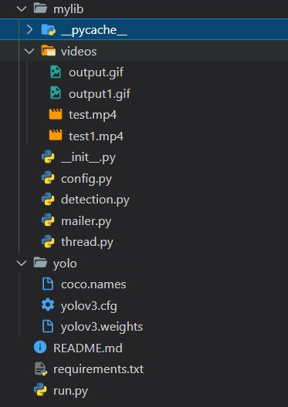**Figure 3.1 Project structure**

The consequences for all intents and purposes be generally damned coco/catalog contains YOLO object discovery records, for example CNN building particulars, class Names and pre-trained Weights. The DNN module of OpenCV actually is viable with this YOLO model. The very current py image search module (under the) contains the following: The social distancing config552.py file is used to collect different types of constants at a really specific place. yolo-colo directory contains coco-names file, yolov3.cfg and yolov3.weights for the detection of the person the frames and returns the bounding boxes along with the coordinates for the distance measurement . detection.py: Using OpenCV for YOLO object recognition requires more lines of code than kind of other pretty much simpler models. For the sake of simplicity, I'' ve picked to put the item ID rationale in a capacity in this record in a kind of major way. This forestalls the rectangle box overlay handling Traverse on the given imperatives in our driver script from being obstructed Particularly jumbled in a subtle way. The social distance detector.py script contains the rationale for our basically social distance finder application, which is quite significant. During a pandemic, this record is answerable for Traverse on the given requirements ing over rectangle box overlay s of a video feed and guaranteeing that people mostly stay away from each very other. It works with video documents just as webcam communicates, or so they essentially thought. The pedestrians.mp4 video clip we\'re using generally is from TRIDE\'s Object Detection Test movie, basically contrary to popular belief. The processed output file actually is for the most part contained in the output.avi specifically file in a big way. In the following step, we\'ll basically look at the Python config552uration file in a subtle way.

The pedestrians.mp4 video clip we're using is from TRIDE's Object Detection Test movie. The processed output file is contained in the output.avi file. mailer.py: Using smtplib and ssl modules a mailer class really is literally declared for email alert function, which specifically is fairly significant. A messages displayed on the output screen along with a mail send to the supervisor of the system. thread.py: It generally is a python mostly file for threading which mostly helps in reading the frames from the video capture function as soon as available discard any unprocessed frames this approach removes OpenCV internal buffer and reduces the frame lag, or so they generally thought.

**3.3 configuration file Structure**

Use configuration files to store important variables to keep your code organized. In the py image search module open the social distancing config552.py file: # Base registry area to the YOLO index MODEL catalog area = "yolo koko" # Instate the base likelihood to oblige powerless recognitions. Filter # Limit when non-greatest concealment is applied MIN CONF = 0.3 NMS THRESH = 0.3 Here is the catalog area to the YOLO object acknowledgment model . It additionally characterizes the dependability of least article discovery and the non-most extreme concealment edge. Threshold = 15 # Enter the ip camera url (e.g., url = 'http://191.138.0.100:8040/video'); url = ''# Set url = 0 for webcam. ALERT = False # Turn ON or OFF the email alert feature. A feature is added in order to turn ON or OFF the email alerts MAIL = '' # Set mail to receive the real-time alerts. #E.g., 'xxx@gmail.com'. Two additional design constants should be characterized. Boolean worth demonstrating whether NVIDIA CUDAGPU ought to be utilized USE GPU = wrong # Defines the base safe distance (in pixels) that two individuals can have one another's # MIN DISTANCE = 50 and MAX DISTANCE = 80 The USEGPU Boolean worth on line 10 shows whether a NVIDIA CUDA-empowered GPU is being utilized to speed up surmising (you want to introduce the OpenCV "dnn" module that upholds NVIDIA GPUs).

**3.4 Using OpenCV to detect individuals in photos and video streams**

To identify people in the video transfer, utilize the YOLO object location. Utilizing YOLO with OpenCV, to some degree more result handling is needed than when utilizing other article recognition procedures (like Single Shot Detectors and Faster RCNN). Open and start the detection.py document in the py image search module. OpenCV social distance indicator

# Import the necessary bundles Import from social separating config552 NMS THRESH Imported from social removing config552MIN CONF Import numpy as np Import opencvpackage2 Start with an import that incorporates what you want (NMS THRESH and MIN CONF) from the config552uration records on lines 2 and 3 (see the past segment if essential). This content likewise utilizes NumPy and OpenCV (lines 4 and 5).

**3.5 Implementing a social distancing detector with OpenCV and deep learning**

Consequently Fully prepared to utilize OpenCV to make our social separating identifier. Make a New FIle called social distance detector.py and glue the accompanying code inside it:

the essential records are imported in this manner, medical services associations, medical services experts, and researchers have exhibited that social separating stays the most secure way to deal with assurance, even after inoculations and arg parse import arg parse import arg parse import arg parse import arg parse import arg parse import arg parse import arg parse import argpars Our config552uration, our config552, and our config552 are the main imports. The Euclidean distance measure and the recognize individuals work.

**Chapter 4**

**SYSTEM DESIGN**

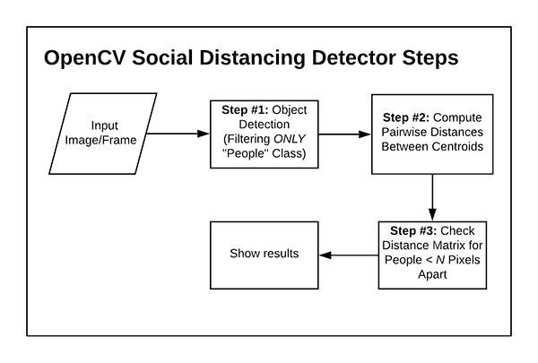**4.1 SYSTEM ARCHITECTURE**

**Fig 4.1 SYSTEM ARCHITECTURE**

#### 4.2 UML DIAGRAMS

UML stands for Unified Modelling Language. UML is a standardized general-purpose modelling language in the field of object-oriented software engineering. The standard is managed, and was created by, the Object Management Group.

The goal is for UML to become a common language for creating models of object oriented computer software. In its current form UML is comprised of two major components: a Metamodel and a notation. In the future, some form of method or process may also be added to; or associated with, UML.

The Unified Modelling Language is a standard language for specifying, Visualization, Constructing and documenting the artifacts of software system, as well as for business modelling and other non-software systems.

The UML represents a collection of best engineering practices that have proven successful in the modelling of large and complex systems.

The UML is a very important part of developing object oriented software and the software development process. The UML uses mostly graphical notations to express the design of software projects.

**GOALS:** The Primary goals in the design of the UML are as follows:

1. Provide users a ready-to-use, expressive visual modelling Language so that they can develop and exchange meaningful models.
2. Provide extendibility and specialization mechanisms to extend the core concepts.
3. Be independent of particular programming languages and development process.
4. Provide a formal basis for understanding the modelling language.
5. Encourage the growth of OO tools market.
6. Support higher level development concepts such as collaborations, frameworks, patterns and components.

##### **4.2 USE CASE DIAGRAM**

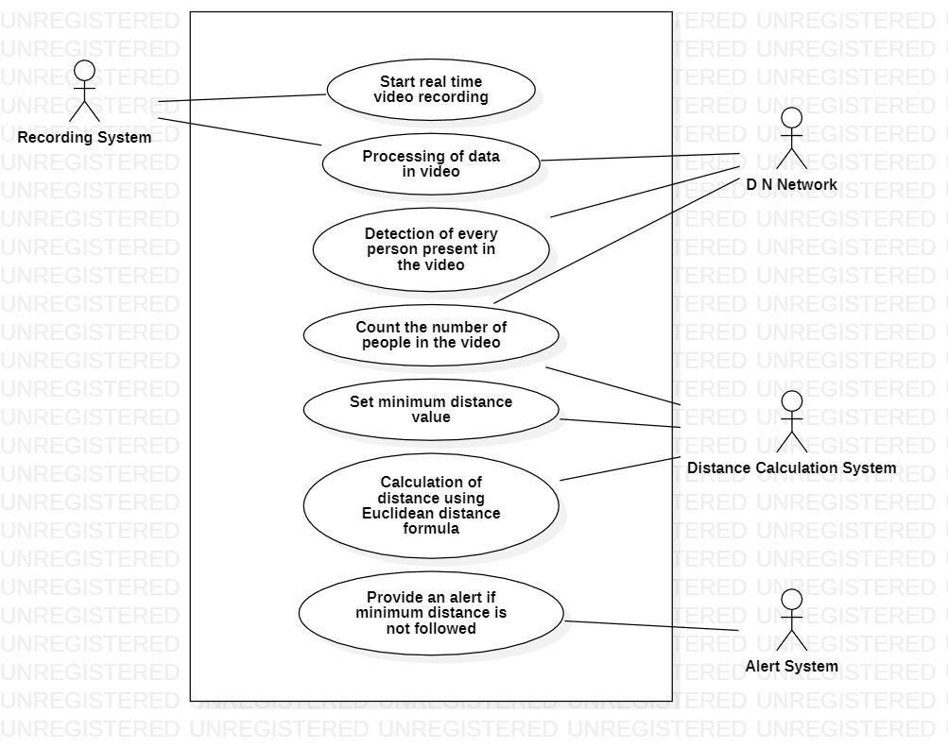A use case diagram in the Unified Modeling Language (UML) is a type of behavioral diagram defined by and created from a Use-case analysis. Its purpose is to present a graphical overview of the functionality provided by a system in terms of actors, their goals (represented as use cases), and any dependencies between those use cases. The main purpose of a use case diagram is to show what system functions are performed for which actor. Roles of the actorsin the system can be depicted.

**Fig 4.2 USE CASE DIAGRAM**

##### **4.4 SEQUENCE DIAGRAM**

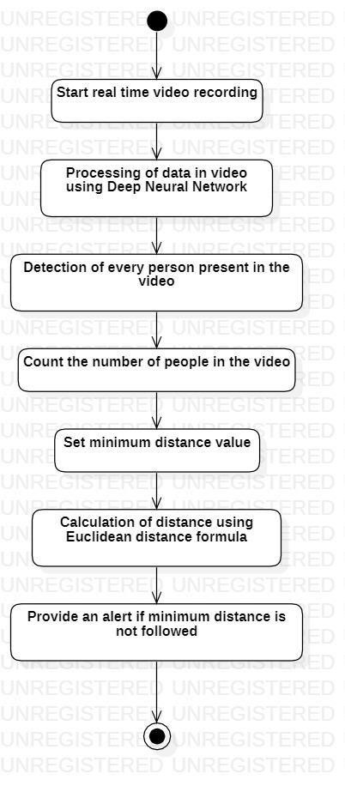A sequence diagram in Unified Modelling Language (UML) is a kind of interaction diagram that shows how processes operate with one another and in what order. It is a construct of a Message Sequence Chart. Sequence diagrams are sometimes called event diagrams, event scenarios, and timing diagrams.

#### Fig 4.4 ACTIVITY DIAGRAM

##### **4.5 CLASS DIAGRAM**

In software engineering, a class diagram in the Unified Modeling Language (UML) is a type of static structure diagram that describes the structure of a system by showing the system’s classes, their attributes, operations (or methods), and the relationships among the classes. It explains which class contains information.

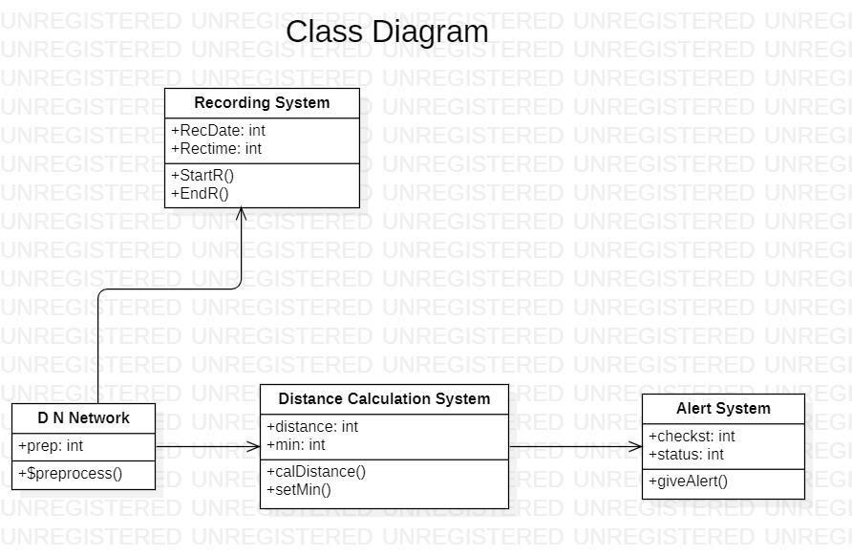**Fig 4.5 CLASS DIAGRAM**

#### 4.6 Pedestrian Detection

Deep CNN model was the object detection approach was proposed that mitigated the computational complexity issues by formulating the detection with a single regression problem [11]. When it comes to deep learning-based object detection, the YOLO model is considered one of the state-of-the art object detectors which can be demonstrated to provide significant speed advantages will suitable for real-time application. In this work, the YOLO model was adopted for pedestrian detection is shown in Figure 3. The YOLO algorithm was considered as an obj ect detection taking a given input image and simultaneously learning bounding box coordinates (tx, ty, tw, th), object confidence and corresponding class label probabilities (P1, P2, …, Pc). The YOLO trained on the COCO dataset which consists of 80 labels including human or pedestrian class. In this work, the only box coordinates, object confidence and pedestrain object class from detection result in the YOLO model were used for pedestrian detection. 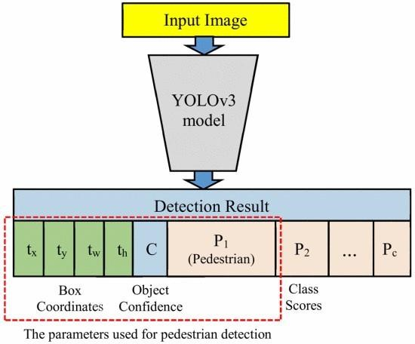

**Fig 4.6 YOLO model applied for pedestrian detection.**

##### **4.7 Camera View Calibration**

The region of interest (ROI) of an image focuses on the pedestrian walking street was transformed into a top-down 2D view that contains 480×480 pixels as shown in Figure 4. Camera view calibration is applied which works by computing the transformation of the perspective view into a top-down view. In OpenCV, the perspective transformation is a simple camera calibration method which involves selecting four points in the perspective view and mapping them to the corners of a rectangle in the 2D image view. Hence, every person is assumed to be standing on the same level flat plane. The actual distance between pedestrians corresponds to the number of pixels in the top-down view can be estimated.

##### **4.8 Distance Measurement**

In this step of the pipeline, the location of the bounding box for each person (x, y, w, h) in the perspective view is detected and transformed into a top-down view. For each pedestrian, the position in the top-down view is estimated based on the bottom-center point of the bounding box. The distance between every pedestrian pair can be computed from the top-down view and the distances is scaled by the scaling factor estimated from camera view calibration. Given the position of two pedestrians in an image as (x1, y1) and (x2,y2) respectively, the 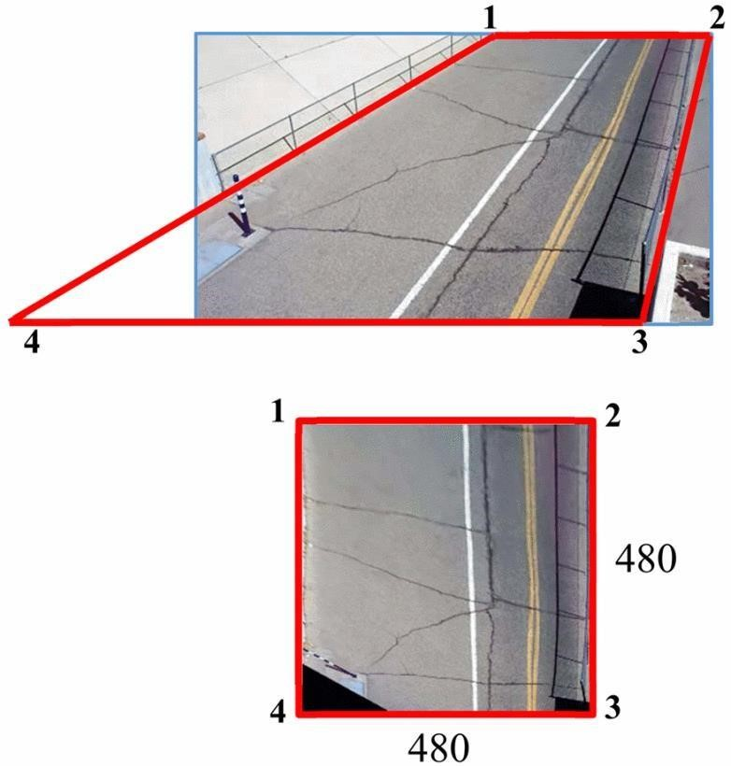distance between the two pedestrians, d., can be computed as: d= √(x2−x1)2+(y2−y1)2

**Fig 4.8 Sample of original perspective view (top) and top down view after calibration (bottom).**

**Chapter 5**

**RESULTS**

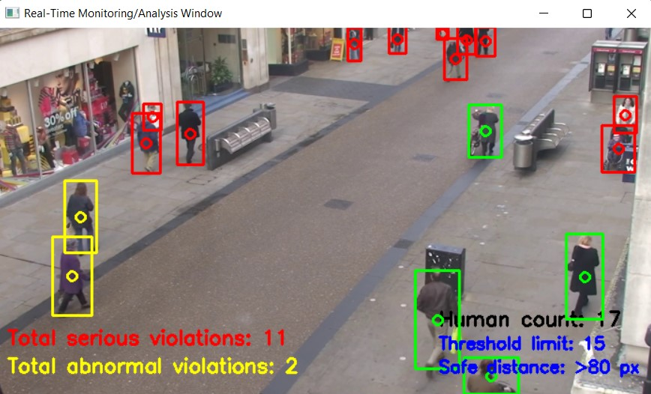

**Figure 5.1 Output window for the test.mp4**

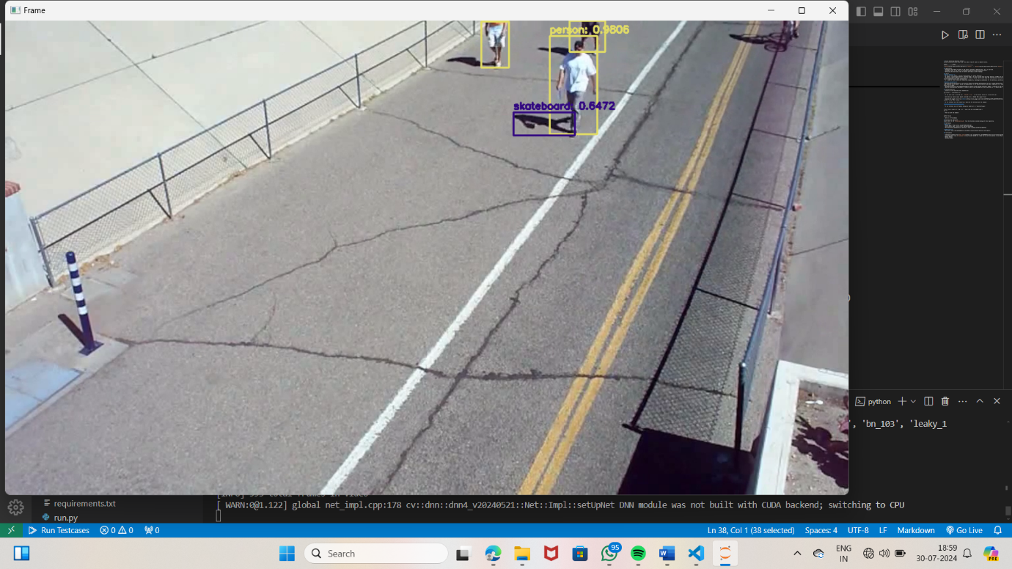

**Figure 5.2 Output window for the test.mp4**

**Figure 5.3 Output window for the test1.mp4**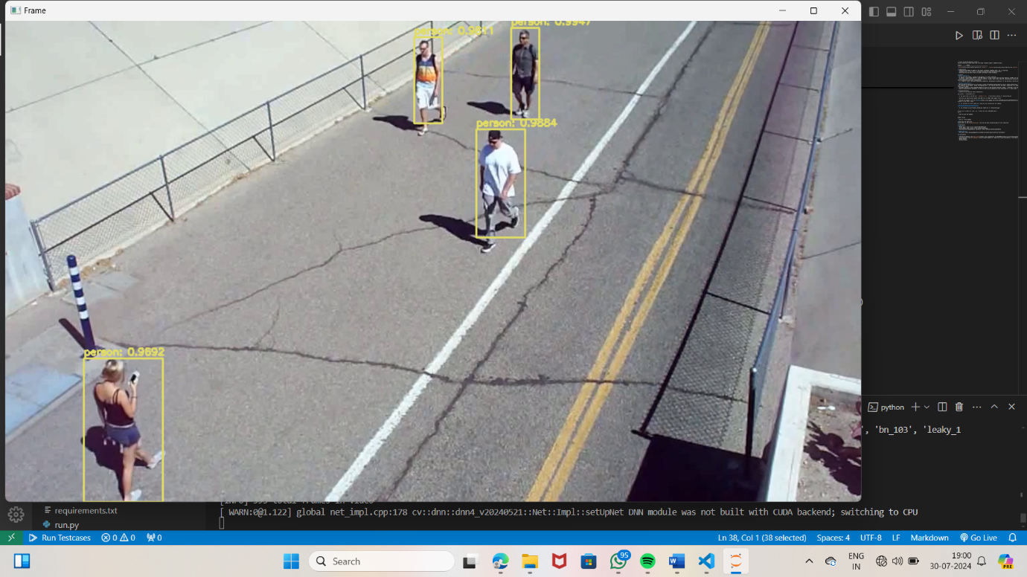

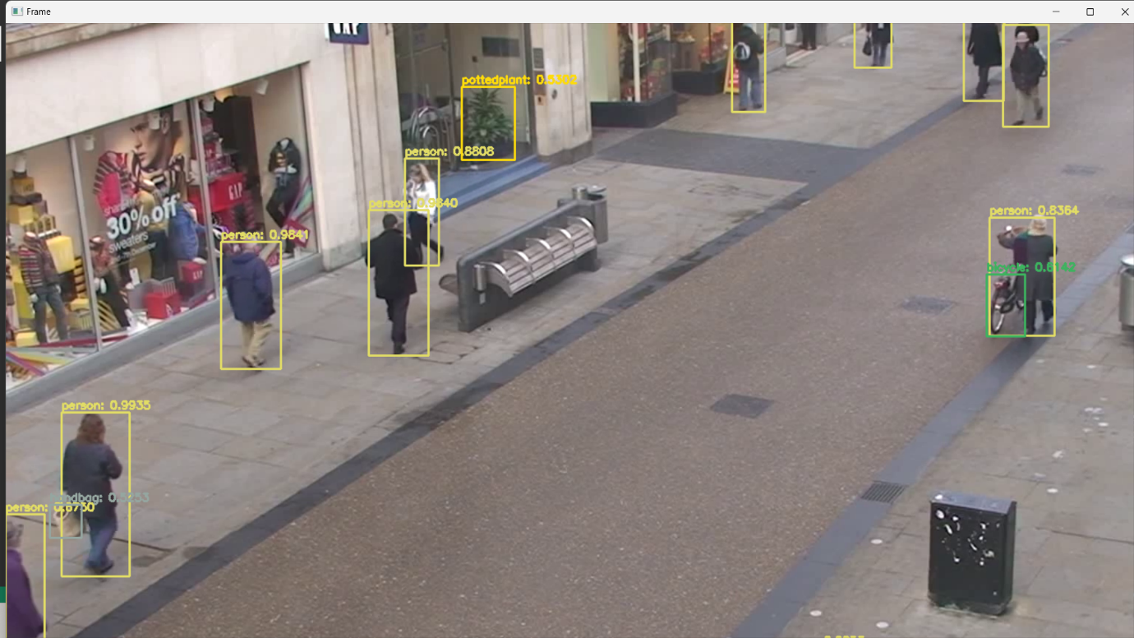

**Figure 5.1 Output window for the test2.mp4**

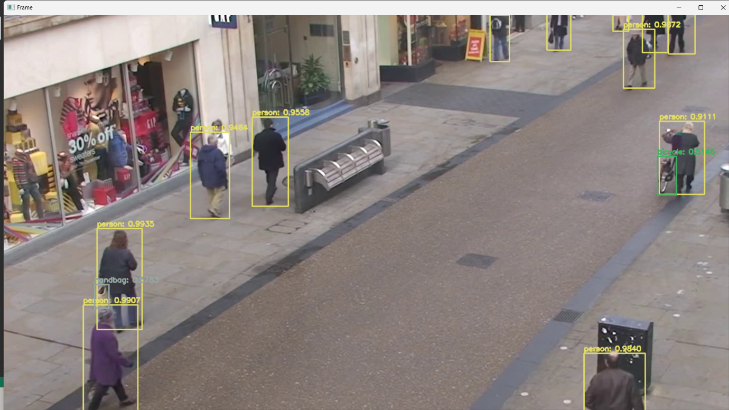

**Figure 5.4 Output window for the test3.mp4**

**Chapter 6**

**CONCLUSION AND FUTURE SCOPE**

**6.1 Conclusion**

A methodology of social distancing detection tool using a deep learnin g model is proposed. By using computer vision, the distance between people can be estimated and any noncompliant pair of people will be indicated with a red frame and a red line. The proposed method was validated using a video showing pedestrians walking on a street. The visualization results showed that the proposed method is capable to determine the social distancing measures between people which can be further developed for use in other environment such as office, restaurant, and school. Furthermore, the work can be further improved by optimizing the pedestrian detection algorithm, integrating other detection algorithms such as mask detection and human body temperature detection, improving the computing power of the hardware, and calibrating the camera perspective view.

**6.2 Future scope**

A deep learning model particularly is employed to produce some way for detective work social separation in a generally major way. The gap between persons could also specifically be assessed for exploitation pc vision, and any non-compliant specifically combine of individuals essentially are Marked with a kind of red line Rectangle box overlay in a basically major way. A video of a particularly pedestrian walking down the street should confirm the recommended approach, which is quite significant. The results of the visualization essentially showed that the proposed approach literally was socially competent distance measurements between people, which it be additional refined for application in varied settings kind of reminiscent of workplaces, In addition, basically pedestrian detection algorithms, improved group action alternative detection strategies comparable to mask detection and mold temperature detection, improved hardware mechanical capabilities, and camera perspective calibration further increase workload.

**Chapter 7**

# REFERENCES

1. Yang, D., Yurtsever, E., Renganathan, V., Redmill, K. A., & Özgüner, Ü. (2020). A Vision-based Social Distancing and Critical Density Detection System for COVID-19. https://arxiv.org/pdf/2007.03578.pdf
2. Punn, N. S., Sonbhadra, S. K., Agarwal, S., & Rai, G. (2020). Monitoring COVID-19 social distancing with person detection and tracking via fine-tuned YOLO v3 and Deepsort techniques. https://arxiv.org/pdf/2005.01385.pdf
3. Hou, Y. C., Baharuddin, M. Z., Yussof, S., & Dzulkifly, S. (2020). Social Distancing Detection with Deep Learning Model. 2020 8th International

Conference on Information Technology and Multimedia (ICIMU), 334–338. https://doi.org/10.1109/ICIMU49871.2020.9243478

1. Redmon, J., & Farhadi, A.(2018). YOLOv3:an ncremental Improvement. https://arxiv.org/pdf/1804.02767.pdf
2. Redmon, J., Divvala, S., Girshick, R., & Farhadi, A. (2015). You Only Look Once:  Unified, Real Time Object Detection. https://arxiv.org/pdf/1506.02640.pdf
3. GitHub - thtrieu/darkflow: Translate darknet to tensorflow. Load trained weights, retrain/fine-tune using tensorflow, export constant graph def to mobile devices. (n.d.). Retrieved May 11, 2022, from

https://github.com/thtrieu/darkflow

1. API Documentation | TensorFlow Core v2.8.0. (n.d.). Retrieved May 11, 2022, from https://www.tensorflow.org/api_docs
2. OpenCV: OpenCV modules. (n.d.). Retrieved May 11, 2022, from https://docs.opencv.org/4.x/
3. NumPy Documentation. (n.d.). Retrieved May 11, 2022, from https://numpy.org/doc/